A Mayor and a Social Anthropologist

Malcolm Kenneth Pridmore was born in October 1869 in Foleshill to parents George and Sophia Pridmore. They ran an Elastic Web manufacturing business at Foleshill Mills in Lockhurst Lane. Malcolm became a solicitor , then a councillor and was mayor of Coventry in 1914 and 1915. This was a difficult time at the beginning of the First World War. The 1911 Census showed him living at the Hollies in Foleshill Road. He had been born just next door in the family home, a house called Brooklyn. Malcolm along with George Poole was responsible for the city’s earliest public housing. George was the son of a watchmaker and Coventry’s first Labour councillor.

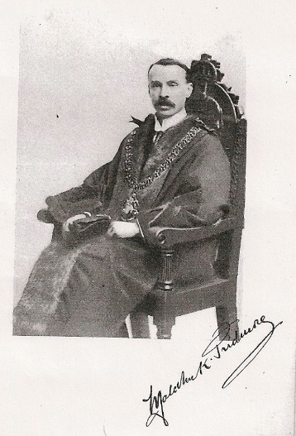

After 30 years of civic service Malcolm died on 30th March 1945. Probate was granted in Birmingham on 23rd May and he bequeathed his total estate of £86,063 16s 5d to Sheila Gadomski ( wife of Zdzislaw Gadomski ) Who was she ? It’s a complicated story.
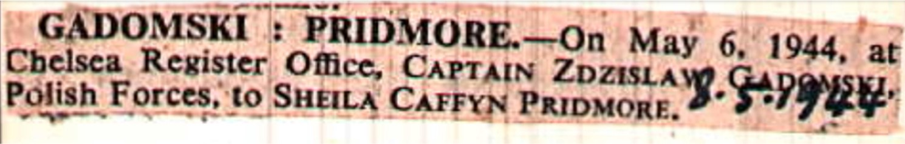
Malcolm had moved to Cromers Close off Kenilworth Road when he married Edith Caffyn ( a widow ) in 1928. His house is now Beauchamp Nursing Home. Edith had a daughter Sheila Caffyn who then became Sheila Caffyn Pridmore. She had married the year before Malcolm died. On May 6th 1944 Sheila married Captain Zdzislaw Gadomski at Chelsea Registry Office. The marriage was short lived and she then married Bruce Tyrell Patterson on 23rd January 1948. Her third husband was Tadeusz Horko a Polish journalist who she married in 1955 in Paddington.
Sheila’s Career :-
Her formal education was at Roedean and then Oxford University. She joined the War Office in 1940, and a year later moved to Poland House in Marylebone London Some years later in 1947 Sheila enrolled at LSE to research S.Africa and wrote a thesis : “The status of the Cape coloured people within the S. African structure”. This led to her writing two books : “Colour and Culture in S. Africa” in 1953 then “The Last Trek” in 1957 using the name Sheila Patterson as the author. A name she continued to use as the author for all her books. Between 1955 and 1959 she researched West Indian settlers living in Brixton leading to another publication called “Dark Strangers”. During this period Sheila had begun employment at The Institute of Race Relations and from 1960 edited their newsletter. This resulted in the release of her final book entitled “Immigration and Race Relations in Britain 1960-67”. Towards the end of her career she became editor of “New Community” in 1971. This was a journal published by the Community Relations Commission, it was intended to bridge the gap between academics and policy makers.
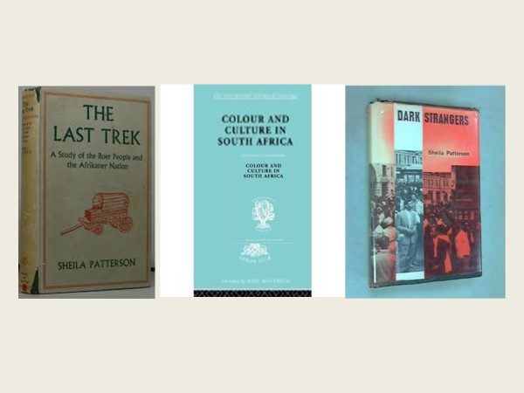

She was described as a striking elegant woman who was basically shy. In the 1970s a friend intimated that Sheila had turned down more speaking invitations than anyone she had ever known. Sheila died after a stroke in a nursing home in Hove Sussex in 1998 but is buried at St Mary’s in Stoneleigh in the Pridmore family plot along with Malcolm Pridmore, her mother Edith, only child Clarissa ( the daughter of Sheila and Bruce Tyrell Patterson ) and third husband Tadeusz Horko.

